**“Shortest Path First”**

**A**

**Project Report**

submitted in partial fulfillment of the

requirements for the award of the degree of

**BACHELOR OF TECHNOLOGY**

**In**

**COMPUTER SCIENCE & ENGINEERING**

**Specialization in**

**Oil and Gas Informatics**

**by**

**Name Roll No.**

**Aditi Singh R970219003**

**Diya Agrawal R970219009**

**Sumit Kumar Rana R970219016**

under the guidance of

**Dr. Niharika Singh**

**C:\Users\aktomar\Desktop\logo.png**

**Department of Computer Science**

**School of Computer Science**

**University of Petroleum & Energy Studies**

**Bidholi, Via Prem Nagar, Dehradun, UK**

**December – 2021**

C:\Users\aktomar\Desktop\logo.png

**CANDIDATE’S DECLARATION**

We here by certify that the project work entitled **“Shortest Path First”** in partial fulfillment of the requirements for the award of the Degree of BACHELOR OF TECHNOLOGY in COMPUTER SCIENCE AND ENGINEERING with specialization in Oil and gas Informatics submitted to the School of Computer Science, Department of Informatics, University of Petroleum & Energy Studies, Dehradun, is an authentic record of our work carried out during a period from **September**,**2021** to **December**,**2021** under the supervision of **Dr. Niharika Singh**.

The matter presented in this project has not been submitted by us for the award of any other degree of this or any other University.

**Name Roll No.**

**Aditi Singh R970219003**

**Diya Agrawal R970219009**

**Sumit Kumar Rana R970219016**

This is to certify that the above statement made by the candidate is correct to the best of my knowledge.

Date:

**Dr. Niharika Singh**

(ProjectMentor)

**ACKNOWLEDGEMENT**

We express our deep gratitude and appreciation to those who agreed to participate in this project, for their time expended and courage in sharing their insights with fledging students. Special thanks to **Dr. Bhagwant Singh** for invigilating and giving us this wonderful opportunity of working on our minor project-1 and also for the time spent on correcting our mistakes and continuous support.

We are immeasurably enriched by working under the mentorship of **Dr. Niharika Singh**, who has great level of knowledge and who has an art of encouraging, correcting, and directing us in every situation. This work would not have been possible without her support and valuable suggestions.

We sincerely thank our Head of the Department, **Dr. Sunil Gupta**, for his great support to us in doing project in our domain at **SoCS**.

At times our studies carried out at great cost to those closest to us.

We all thank our families and fellow batch mates for their best understanding and support.

We acknowledge to all the people who are involved in this beautiful journey of project and those who supported us till project’s completion.

**TABLE OFCONTENTS**

|  |  |  |
| --- | --- | --- |
| **S.No.** | **Index** | **Page no.** |
| 1 | Abstract | 5 |
| 2 | Introduction | 6 |
| 3 | Problem Statement | 7 |
| 4 | Explaining Tools and techniques | 7-8 |
| 5 | Objectives | 8 |
| 6 | Purpose And Motivation | 8 |
| 7 | Methodology | 9 |
| 8 | Algorithm | 9-10 |
| 9 | Flow Chart | 10 |
| 10 | Code Snippet | 11-12 |
| 11 | Output | 12-13 |
| 12 | Result | 13 |
| 13 | Conclusion | 14 |
| 14 | References | 14 |

1. **ABSTRACT**

Increased demand of restaurant-goers generated the need for much attention for the hospitality industry. Providing much option with ease of ordering and delivering is the need of the hours. Technological interference has become mandatory to improve the quality of the service and business in this industry. Evidences are already existed for partial automation of food ordering process in the country; most of these technologies implemented are based on wireless technologies.

Sometimes you don’t feel like cooking or doesn’t feel like to go to the restaurants; therefore we here propose an Online Food Ordering Management System which can help the customers to get food delivered immediately. An Online Food Ordering System is proposed here which simplifies the food ordering process. The proposed system shows a user interface and updates the menu with all available options so that it eases the customer work. Customer can choose more than one item to make an order and can view order details before logging off. The order confirmation is sent to the customer. The order is placed in the queue and updated in the database and returned in real time. This system assists the staff to go through the orders in real time and process it efficiently with minimal errors.

This is mostly designed for a single restaurant having various food items at valuable food price. It gives effective way to order your food and almost within no time food will be delivered. Customer, he/she has login form with password in order to secure the information details and then after selecting desired delivery point program will recommend the nearest restaurant for fastest delivery which lead to the selection of restaurant; therefore will show the route followed by t8he delivery man and estimated time taken of delivery keeping in mind the congestions like slope, highways, traffic etc. Furthermore user can select his/her favorite food items, place the order, also mention the quantity and finally can make the payment. When the order is placed, it gets stored in the database of the restaurants and then the staffs go through the orders and process it efficiently.

The conclusion of this project is to help customer in making order easily, to give detail information needed by customer, to help restaurant in receiving order, and to help courier while doing delivery.

1. **INTRODUCTION**

In a world where staying home is the new normal, ordering food online has become more of a habit than an occasion. Everyone likes a fast and simple interface to order their cravings.

The online food ordering system sets up a food menu online and customers can easily place the order as per they like. Also with a food menu, online customers can easily track the orders. The management maintains customer’s database, and improve food delivery service. The Restaurant management system motivates us to develop the system. There are various facilities provided so that the users of the system will get service effectively. Increasing use of smart phones is also considered as a motivation, so that any users of this system get all service on single click. Another motivation can be considered as the system will be designed to avoid users doing fatal errors, users can change their own profile, users can track their food items through GPS, users can provide feedback and recommendations and can give ratings, it will give appropriate feedbacks to Restaurants. Due to lack of a full fledge application that can fulfill the customer requirements by providing him food from restaurants as well as from mess service, there is a need for the system.

This proposed system will be used by the people who keep shifting from cities to cites. As well as, it will be useful for the students studying in different cities. The proposed system will provide the flexibility to the Customers/Users to order from Restaurants. It will also provide recommendations of nearest restaurants to the customers. In the proposed system, there will be no limitation on the amount of order the customer wants. Also, same application can be used as a Startup Business for the developers. It will provide real time customers’ feedback and ratings along with the comments to the restaurants/mess owner. It gives appropriate feedbacks to users, so if there is any error happened, and then there will be a feedback dialog toward users. The proposed system is designed to avoid users doing fatal errors and inappropriate action. Scope of proposed system is justifiable because in large amount peoples are shifting to different cities so wide range of people can make a use of proposed system. The system/interface will take input from the user. The major attributes that will give input to the dataset are: name, address, email-Id, mobile no, other personal related values, etc. The output will include user/customer’s Order, Bill and Payment options and the shortest route followed by the delivery man with the estimated time that will be taken by him/her.

The reason why to choose this project is the idea behind project that is to solve problem of late arrival of food.

This problem arises due to various factors, but a major one is taking the longer route or getting stuck in traffic. Thus comparing multiple routes and coming up with the shortest and efficient one is invaluable. This system is for making efficient communication between consumer and producer of the food system which will then leads to the ideal and effective system.

1. **PROBLEM STATEMENT**

The problem with food service industry is that restaurants are not realizing the efficiencies that would result from better application of technology in their daily operations such as identifying an efficient and effective route for multiple deliveries along the path.

1. **EXPLAINING TOOLS AND TECHNIQUES**
   1. **C++**

**C++** is one of the world's most popular programming languages. C++ is a general-purpose programming language created by BjarneStroustrup as an extension of the C programming language, or "C with Classes". The language has expanded significantly over time, and modern C++ now has object-oriented, generic, and functional features in addition to facilities for low-level memory manipulation. It is almost always implemented as a compiled language, and many vendors provide C++ compilers, including the Free Software Foundation, LLVM, Microsoft, Intel, Oracle, and IBM, so it is available on many platforms.

C++ was designed with an orientation toward system programming and embedded, resource-constrained software and large systems, with performance, efficiency, and flexibility of use as its design highlights. C++ has also been found useful in many other contexts, with key strengths being software infrastructure and resource-constrained applications, including desktop applications, video games, servers (e.g. e-commerce, web search, or databases), and performance-critical applications (e.g. telephone switches or space probes).

C++ can be found in today's operating systems, Graphical User Interfaces, and embedded systems. It is an object-oriented programming language which gives a clear structure to programs and allows code to be reused, lowering development costs. C++ is portable and can be used to develop applications that can be adapted to multiple platforms. As C++ is close to C# and Java, it makes it easy for programmers to switch to C++ or vice versa. C++ is a cross-platform language that can be used to create high-performance applications. C++ gives programmers a high level of control over system resources and memory. The language was updated 3 major times in 2011, 2014, and 2017 to C++11, C++14, and C++17 respectively.

* 1. **Dataset**

A **data set** (or **dataset**) is a collection of data. In the case of tabular data, a data set corresponds to one or more database tables, where every column of a table represents a particular variable, and each row corresponds to a given record of the data set in question. The data set lists values for each of the variables, such as height and weight of an object, for each member of the data set. Data sets can also consist of a collection of documents or files.

Several characteristics define a data set's structure and properties. These include the number and types of the attributes or variables, and various statistical measures applicable to them, such as standard deviation and kurtosis. The values may be numbers, such as real numbers or integers, for example representing a person's height in centimeters, but may also be nominal data (i.e., not consisting of numerical values), for example representing a person's ethnicity. More generally, values may be of any of the kinds described as a level of measurement. For each variable, the values are normally all of the same kind. However, there may also be *missing values*, which must be indicated in some way.

In statistics, data sets usually come from actual observations obtained by sampling a statistical population, and each row corresponds to the observations on one element of that population. Data sets may further be generated by algorithms for the purpose of testing certain kinds of software. Some modern statistical analysis software such as SPSS still presents their data in the classical data set fashion. If data is missing or suspicious an imputation method may be used to complete a data set.

1. **OBJECTIVE**

* Analysis of the shortest path from source node to destination by comparative study of shortest path calculation algorithms and time calculation on basis of several factors like congestion, slopes, highways, road condition to generate time efficient system.
* To increase user interaction, system portability and time saving capacity.

1. **PURPOSE AND MOTIVATION**

* The program aims to find the shortest route between a restaurant and customer by comparing two different algorithms to ensure the best optimality.
* It also suggests nearby restaurants to users from their delivery points.
* The program is designed to calculate time based on several factors.
* The area of application for this program can be on any practical food ordering website/application existing or upcoming.
* Another application of the project can be for any application performing network analysis.

1. **METHODOLOGY**

The application starts by displaying the login or registration form. If the user is ordering for first time then, he/she has to first ‘Register’ and then they can start viewing the deals. Else, if it’s not their first time then they have to ‘Login’ with all the credentials such as filling his/her first name, last name, phone number, Email Id, address and password.

Once user has successfully logged in, they will be able to see the ‘Home page’ with a dashboard of menus, orders and food cart, delivery points list and restaurants list. They have to choose the delivery point where the order will be delivered then program will recommend the nearest restaurants, afterwards they have to choose their favorite restaurant according to which program will tell the user the path followed by the delivery man and calculated time depending upon the congestion like traffic, slopes, highways etc. Then user need to choose their favorite dishes from the menu, then place their favorite dishes in the food cart, this food cart will help them to customize the orders like increasing the quantity, removing the food items etc. Once he/she is done customizing their orders, they can checkout and will be redirected to the final order page including their personal details, their orders, total amount to be paid with appropriate payment method. Lastly, they can just pay the amount by selecting the payment method of their choice and simply log-out.

1. **ALGORITHMS**

In this project we have used three algorithms namely Dijkstra Algorithm, Travelling Salesman Algorithm and Time Calculation Algorithm which is a self constructed algorithm.

* 1. Dijkstra Algorithm

Dijkstra's algorithm allows us to find the shortest path between any two vertices of a graph. It differs from the minimum spanning tree because the shortest distance between two vertices might not include all the vertices of the graph.

Dijkstra algorithm is a single-source shortest path algorithm. Here, single-source means that only one source is given, and we have to find the shortest path from the source to all the nodes.

* 1. Travelling Salesman Problem

The Travelling Salesman Problem (TSP) is the problem of finding the shortest path that visits a set of customers and returns to the first. The traveling salesman problem (TSP) is an algorithmic problem tasked with finding the shortest route between a set of points and locations that must be visited. In the problem statement, the points are the cities a salesperson might visit. The salesman‘s goal is to keep both the travel costs and the distance traveled as low as possible.

* 1. Time Calculation Algorithm

It is a self constructed algorithm in which time is calculated according to various factors such as slopes, highways, traffic etc. This algorithm is used to calculate the time taken by the delivery man by different modes of transport like car, bicycle and bike also the delay caused by congestion.

1. **FLOWCHART**

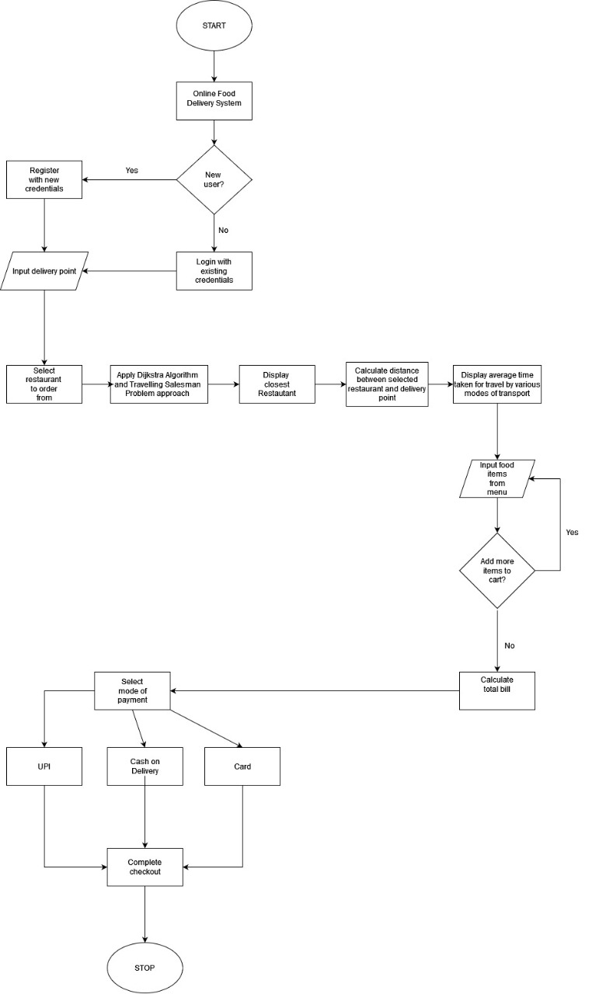

1. **CODE SNIPPETS**

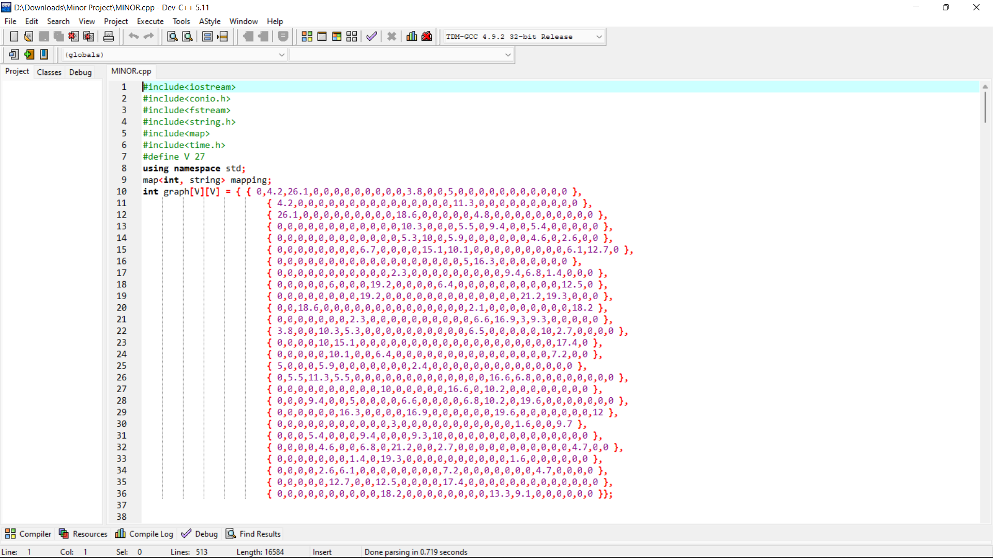

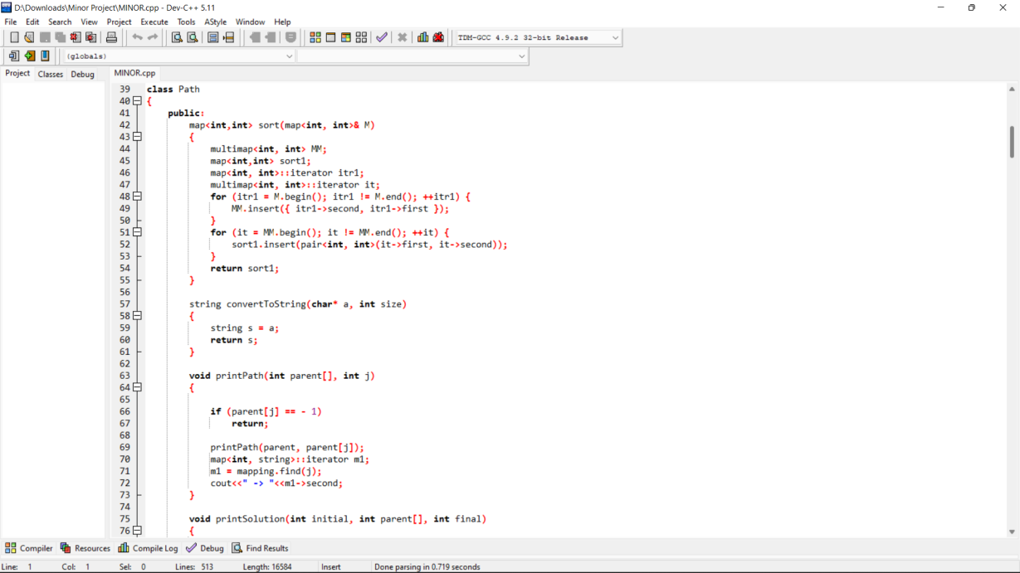

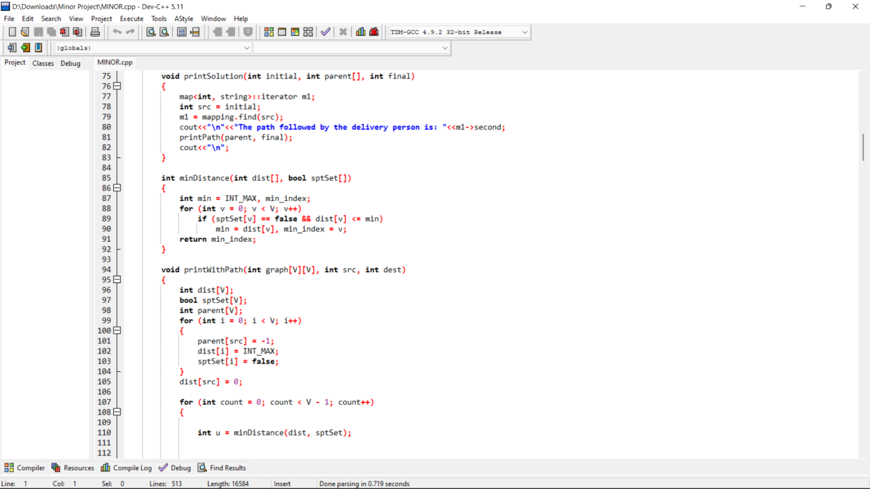

1. **OUTPUT**

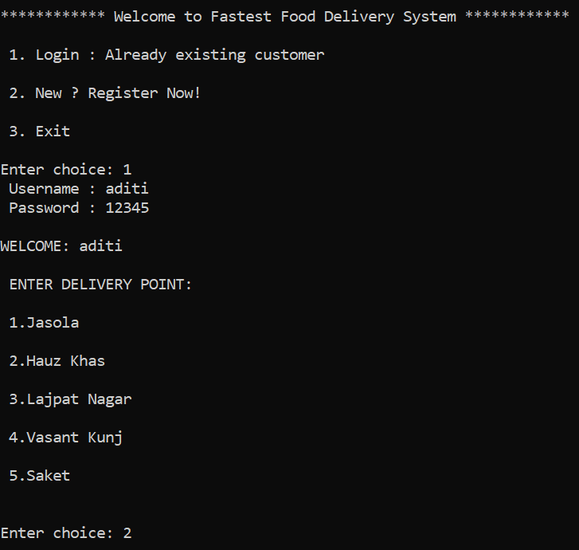 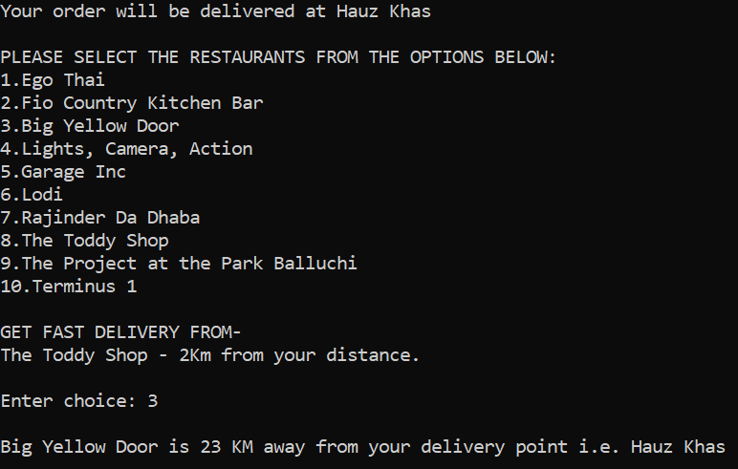

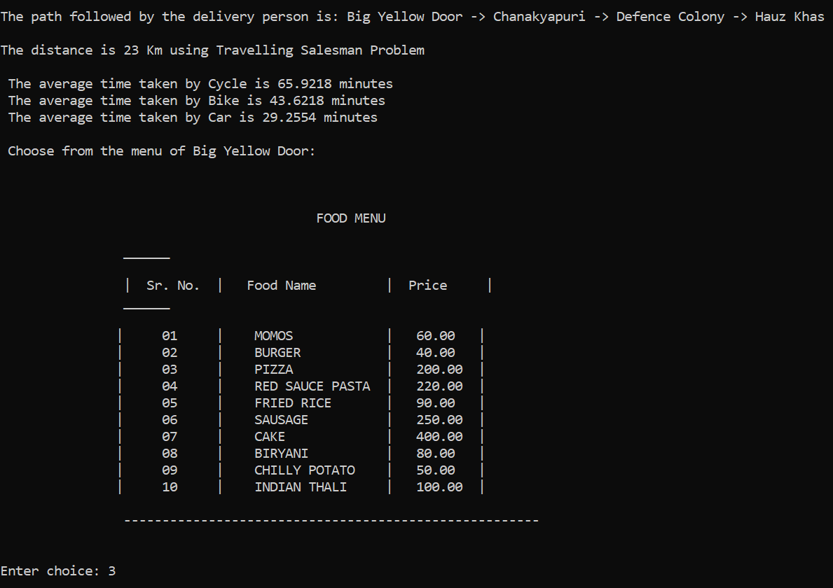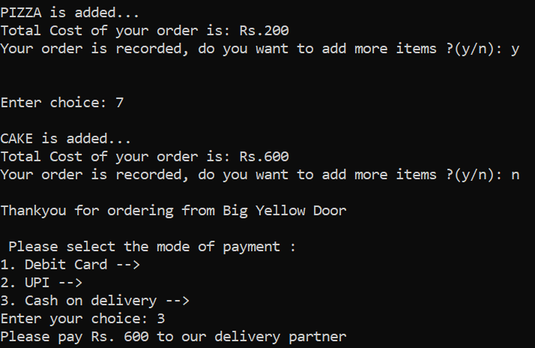

1. **RESULT**

Below are some of the results/consequences obtained from this online food ordering management system software -

* Offering Online food ordering helps the customers to place order more conveniently.
* Traditional long queues to fetch the food or the take-outs will no longer exist.
* This proposed system can even be used by the customers with no such technical background.
* Labor work is almost reduced.
* Also, people can have food from their favorite restaurants. Just ‘one click’ and their favorite restaurants delicious food will be right at the door.
* Last but not least, it saves the customer time and that time can be used by customers into something more productive.

1. **CONCLUSION**

In this report, we have presented that why and how the online food ordering systems can be used and built. This online food ordering systems is built for the customers who are dealing with busy lives; this could help them to save some of their time. With private login system customer can place a secure online order and also can view or receive the updates in real-time. It allows the customers to navigate through the menus and customize their orders. Our experience in developing this software was to show the abilities of wireless communication and in refining the business management and decent service delivery. Generally, the customers who keep on visiting the restaurants are facing problems may be in terms of time, weather, etc. By this application the customer can access their adored food in their place itself. Moreover, this application is useful to all the introverts who hesitate to interact with others. This application recommends the nearest restaurants so that user needs not to waste their time in choosing a restaurant. Adding to which this application does not take much time to order or the delivery of food as it will calculate the estimate delivery time by calculating the delay due to congestion. It is very simple to use and it gives an efficient way also. This designed project is customer friendly and can be used efficiently for storing the customer details, orders, payment options, etc. Thus, this system is user-friendly, convenient and effective so that improves the restaurants performance.

1. **REFERENCES**

* Let Us C++ by Yashwant Kanetkar
* <https://www.geeksforgeeks.org/dijkstras-shortest-path-algorithm-greedy-algo-7/>
* <https://www.google.com/maps>
* https://www.interviewbit.com/blog/travelling-salesman-problem/